Đề thi số 3 – Mức độ thông hiểu và vận dụng
Thời gian làm bài: 40 phút

Question 1. Vocabulary & Phonics – Choose the correct answer
1. A place where students read books is a ______.
A. library B. playground C. garden
2. The day before Sunday is ______.
A. Friday B. Saturday C. Monday
3. Choose the word with a different sound.
A. book B. cook C. look D. school
4. We play football on the ______.
A. playground B. library C. classroom
5. The opposite of "big" is ______.
A. tall B. small C. long

Question 2. Grammar – Find and correct the mistake
- She can plays badminton.
- I have Maths in Monday.
- There is two libraries at my school.
- Where was you last summer?
- He like English because it's interesting.
Question 3: Look and write
1.
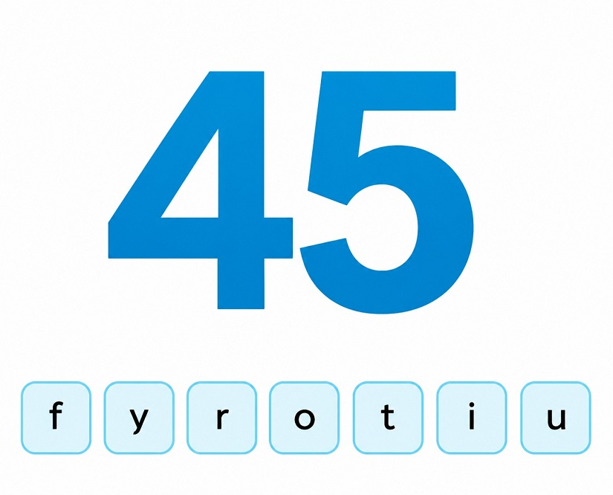
2.
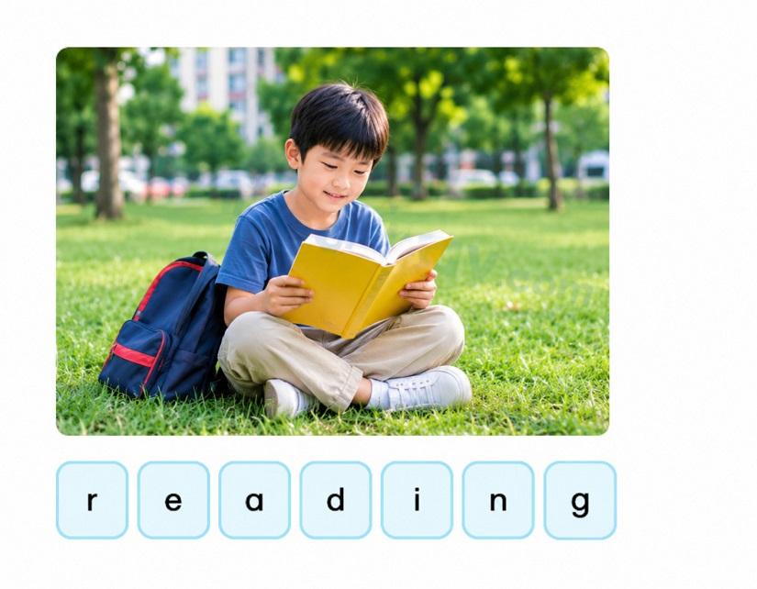
3.
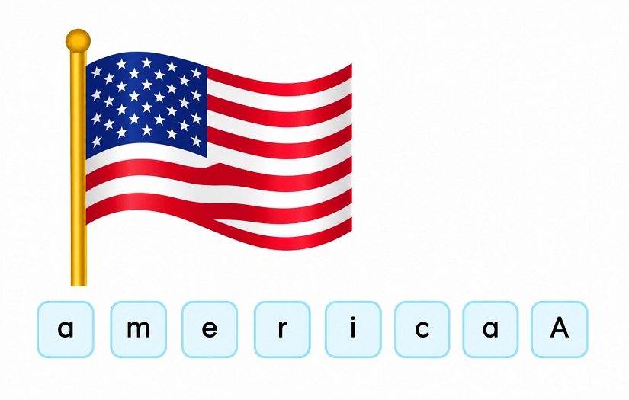
4.
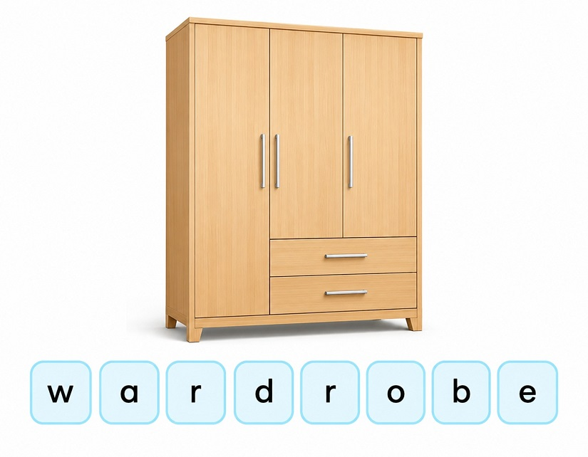

Question 4. Reading – Read and answer the questions
My name is Ben. I am in class 4B. My school is in the city. It has twenty classrooms, a library and two playgrounds. I have English on Mondays and Wednesdays. I like PE because I love playing sports. Last summer, I was in Da Nang with my family. We went swimming and played on the beach.
- Which class is Ben in?
- Where is his school?
- How many playgrounds does his school have?
- Why does he like PE?
- Where was he last summer?

Question 5. Sentence Building – Make sentences using the given words
- I / get up / at six o'clock.
- My favourite subject / be / English.
- There / be / two playgrounds / at my school.
- I / can / play badminton.
- Last summer / I / be / in Da Nang.

Question 6. Writing – Write about your school
Write 4 - 5 sentences about your school. You can use these suggestions:
- What is the name of your school?
- Where is your school?
- How many classrooms are there?
- What subjects do you like?
- What can you do at school?

