Đề thi số 1 - Mức độ cơ bản
Thời gian làm bài: 40 phút
Question 1. Vocabulary & Phonics – Choose the correct answer
1. Which word is different?
A. Monday B. Friday C. English D. Sunday
2. Which word is different?
A. Japan B. America C. Australia D. Birthday
3. Choose the word with a different sound.
A. cake B. name C. bag D. game
4. What subject do you use numbers in?
A. Maths B. Art C. Music D. PE
Question 2: Look, read the word/phrase and decide if it is T (True) or F (False).
1. Skate

2. Friday
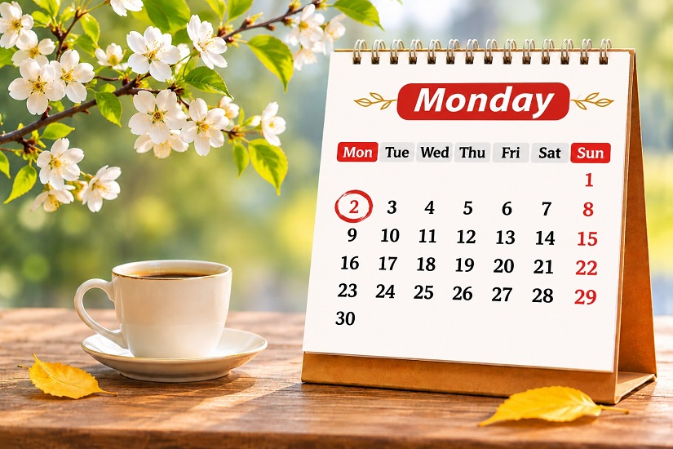
3. Play the guitar

4. Playing video games

Question 3. Grammar – Choose the correct answer
1. What time ______ you go to school?
A. do B. does C. are
2. I have English ______ Monday.
A. in B. on C. at
3. My sister can ______ a bike.
A. rides B. riding C. ride
4. When's your birthday? – It's ______ June.
A. in B. on C. at
5. What do you want to drink? – I want some ______.
A. apples B. juice C. rice
Question 4. Reading – Read and choose True or False
Hello! My name is Anna. I'm ten years old. I'm from Australia. I study at Green Primary School. I get up at six thirty every morning. I go to school at seven fifteen. My favourite subject is English. On Saturdays, I play badminton with my friends.
- Anna is ten years old. ______
- She is from Japan. ______
- She studies at Green Primary School. ______
- She gets up at seven fifteen. ______
- She plays badminton on Saturdays. ______
Question 5. Sentence Building – Reorder the words
- from / Where / you / are / ?
- birthday / My / in / is / October / .
- can / swim / I / .
- subjects / What / like / you / do / ?
- football / on / play / I / Sundays / .
Question 6. Writing – Complete the sentences
- My name is __________________.
- I am __________________ years old.
- My birthday is in __________________.
- My favourite subject is __________________.
- I can __________________.

