Đề thi học kì 1 tiếng Anh lớp 5 Global Success số 2
Tải miễn phí đề số 2 file Word và PDF
Thời gian làm bài gợi ý: 40 phút
PART 1. Choose the correct answer
1. What nationality are you? – I'm ______.
A. Vietnam B. Vietnamese C. English D. Japan
2. How often do you play football? – I play football ______.
A. yesterday B. tomorrow C. twice a week D. last Sunday
3. My sister wants to be a ______ because she loves teaching children.
A. teacher B. farmer C. pilot D. singer
4. There ______ two computers in my classroom.
A. is B. am C. are D. be
5. What are you doing? – I am ______ a book.
A. read B. reads C. reading D. readed
6. The science room is ______ the art room and the library.
A. between B. under C. behind D. in
7. We visited the ______ and learned about many animals.
A. zoo B. kitchen C. bedroom D. bathroom
8. What did you do on your school trip? – We ______ many interesting places.
A. visit B. visits C. visited D. visiting
PART 2. Match the questions with the correct answers
Questions | Answers
1. What is your favourite subject? | A. She wants to be a doctor.
2. Where does your mother work? | B. It's English.
3. What does your sister want to be? | C. I went to the museum.
4. What did you do last Sunday? | D. She works in a hospital.
5. How often do you go swimming? | E. Twice a week.
PART 3: Look, read and choose the correct sentences.
1. What is the girl doing?

A. She is walking two dogs.
B. She is riding a bike.
C. She is playing with two cats.
2. What do you do in your free time?

A. I enjoy playing the piano and listening to music.
B. I usually go to school by bicycle.
C. I often help my mother cook dinner.
3. Where do you live?
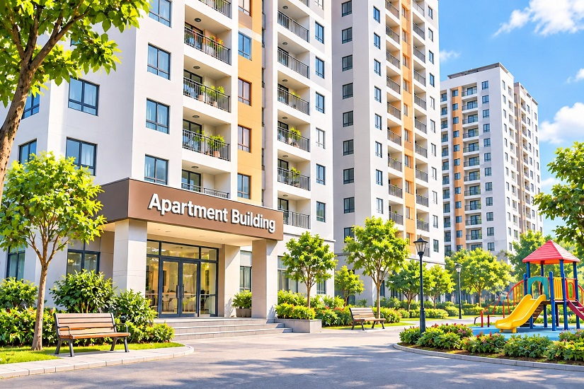
A. I don't live in a house in the countryside.
B. I live in a modern flat in the city.
C. I live in a small village near the mountains.
PART 4. Complete the sentences
behind – usually – astronaut – doing – museum
- My brother wants to be an __________ in the future.
- What are you __________? – I'm reading a story.
- The garden is __________ the school building.
- I __________ go cycling with my friends after school.
- We visited a history __________ yesterday.
PART 5. Read the passage and answer the questions
My name is Nam. I am a pupil at Green Primary School. My school is big and beautiful. There are many classrooms, a library, a computer room and a music room. I like the computer room because I enjoy learning with computers. At break time, I often play chess with my friends. Last week, my class went on a school trip to a farm. We saw cows, chickens and ducks. We also learned how farmers grow vegetables.
- What is the name of Nam's school?
- What rooms are there in his school?
- Why does Nam like the computer room?
- What does he often do at break time?
- Where did his class go last week?
PART 6. Make questions for the underlined words
- I live in the countryside.
- My favourite subject is English.
- My father is a doctor.
- I play badminton twice a week.
- We visited the zoo last Sunday.

