Đề số 4
Part 1: Complete the sentences
Sử dụng từ gợi ý: pilot, village, English, badminton, address.
- I live in a small ______.
- My ______ is 10 Nguyen Hue Street.
- I speak Vietnamese and ______.
- I often play ______ with my friends.
- My brother would like to be a ______ in the future.
Part 2: Read and choose the correct answer
My name is Hoa. I live in a village in northern Vietnam. My house is near a river. I go to school from Monday to Friday. In my free time, I often help my mother with the housework and read books. When I grow up, I'd like to be a doctor to help sick people.
6. Where does Hoa live?
A. In a city
B. In a village
C. In Australia
D. Near a school
7. What is near her house?
A. A river
B. A hospital
C. A cinema
D. A park
8. When does she go to school?
A. On the weekends
B. On Sundays
C. From Monday to Friday
D. Every evening
9. What does she do in her free time?
A. She plays tennis.
B. She watches films.
C. She swims.
D. She helps her mother and reads books.
10. What would she like to be?
A. A teacher
B. A pilot
C. A doctor
D. A farmer
Part 3: Look at the picture and choose the correct answer
11. What do you do in your free time?

- I like reading books.
- I like playing football
- I like cleaning house
12. Where are you from?

- I'm from Australia
- I'm from Viet Nam
- I'm from America
13. What would you like to be in the future?
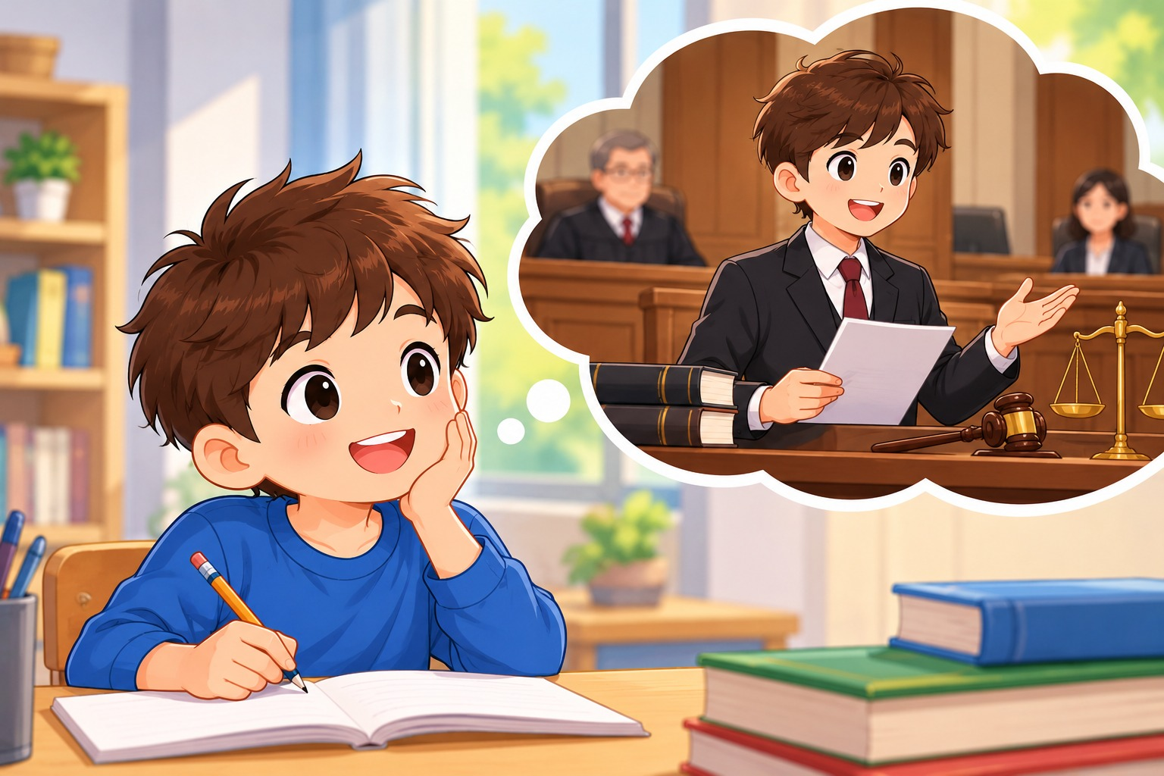
- I'd like to be a lawyer
- I'd like to be a teacher
- I'd like to be a doctor.
14. What language does she speak?

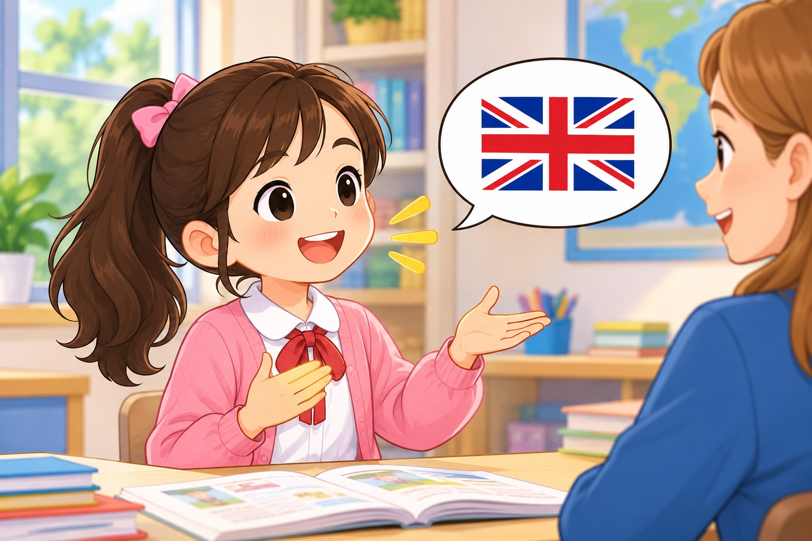
- She speaks Japanese.
- She speaks Vietnamese
- She speaks English
15. Where do you live?
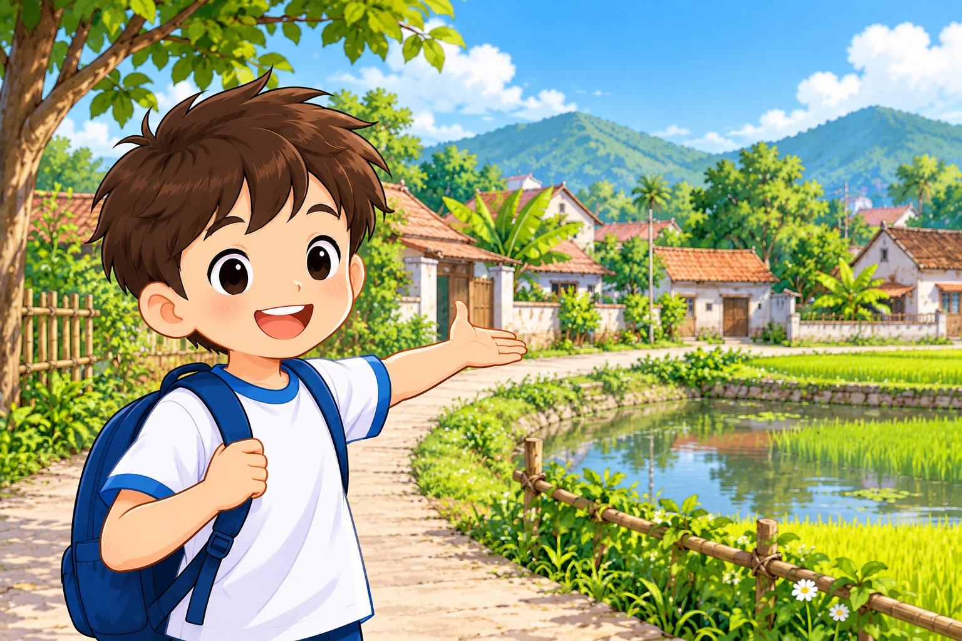
- I live in a small village.
- I live in a big city
- I live with my parents.
Part 4: Rearrange the words
16. from / Where / you / are / ?
17. usually / I / football / play / .
18. would / What / like / you / to be / ?
19. speaks / English / My friend / .
20. in / live / a city / They / .

