Đề số 2
Part 1: Choose the correct answer
1. Where ______ you live?
A. do B. does C. is D. are
2. My brother ______ in a small village.
A. live B. lives C. living D. to live
3. What ______ you do in your free time?
A. are B. does C. do D. is
4. She would like ______ a doctor in the future.
A. be B. being C. to be D. is
5. What language does Peter speak? – He ______ English.
A. speak B. speaks C. speaking D. to speak
Part 2: Read and choose True or False
My name is Nam. I'm eleven years old. I live in Da Nang with my family. In my free time, I often play football with my friends. I also enjoy reading English stories. In the future, I'd like to be a pilot because I want to travel to many countries.
6. Nam is ten years old.______
7. He lives in Da Nang._______
8. He often plays football in his free time.______
9. He dislikes reading English stories.______
10. He would like to be a pilot._____
Part 3: Look and choose the sentences that matches the picture
11. 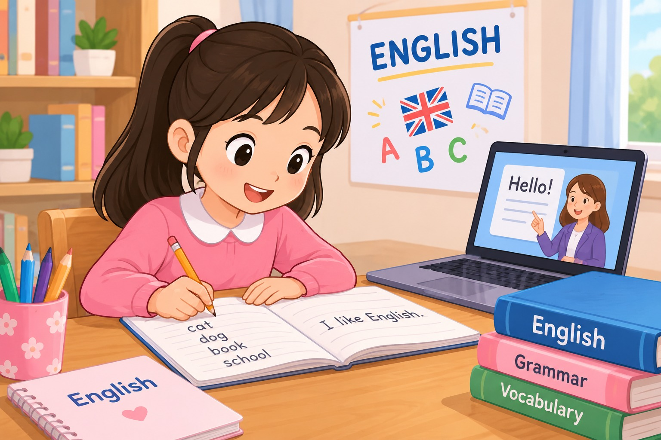
- She likes reading books
- She likes playing guitar
- She likes studying English
12.

- He would like to be a pilot.
- He would like to be a firefighter.
- He would like to be a farmer.
13.
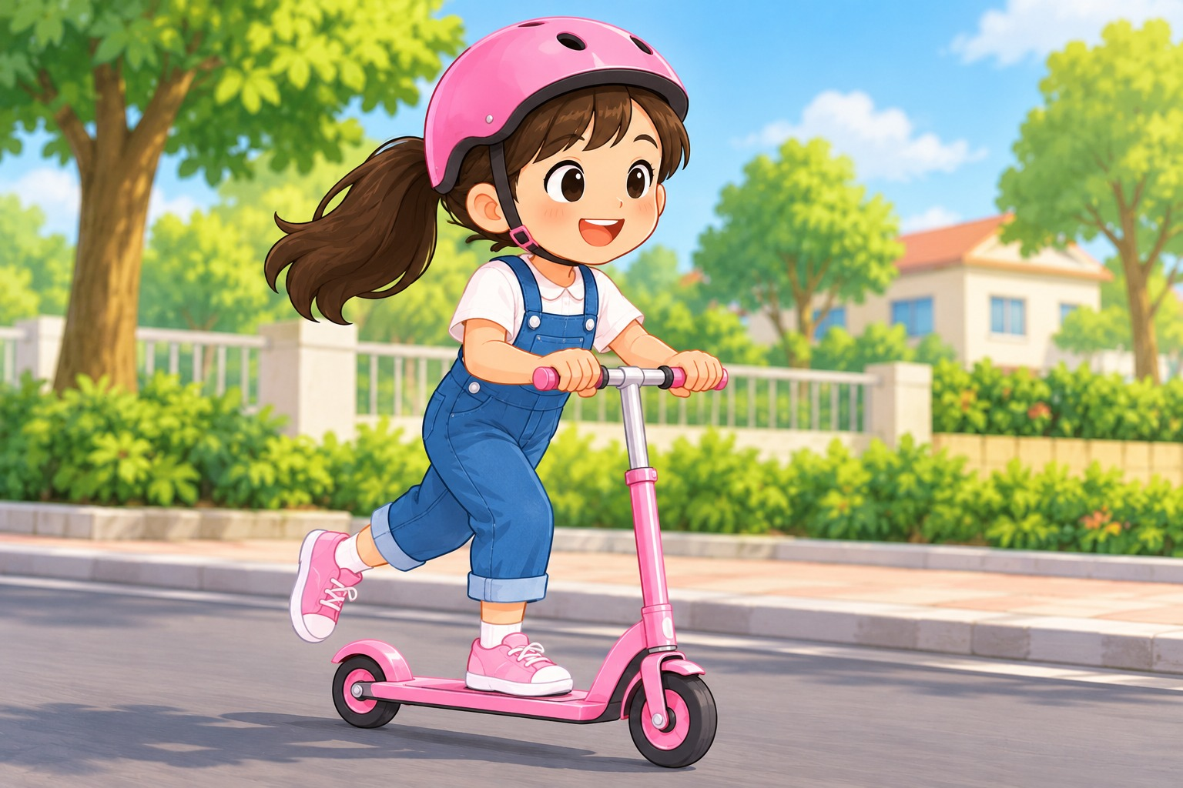
- She is skating in the park.
- She is jumping rope.
- She is riding a scooter.
15.

- He is writing a letter.
- He is doing his homework.
- He is washing his bike.
Part 4: Match the questions with the answers

Column A | Column B
16. What's your name? | A. I live in Hanoi.
17. How old are you? | B. I speak Vietnamese.
18. Where do you live? | C. My name is Linda.
19. What language do you speak? | D. I'd like to be a teacher.
20. What would you like to be in the future? | E. I'm ten years old.

Part 5. Write the answers about yourself
21. What's your name?
22. Where do you live?
23. What do you do in your free time?
24. What language do you speak?
25. What would you like to be in the future?

