Đề số 4
PART 1. Look at the pictures and choose the correct words. (2 points)
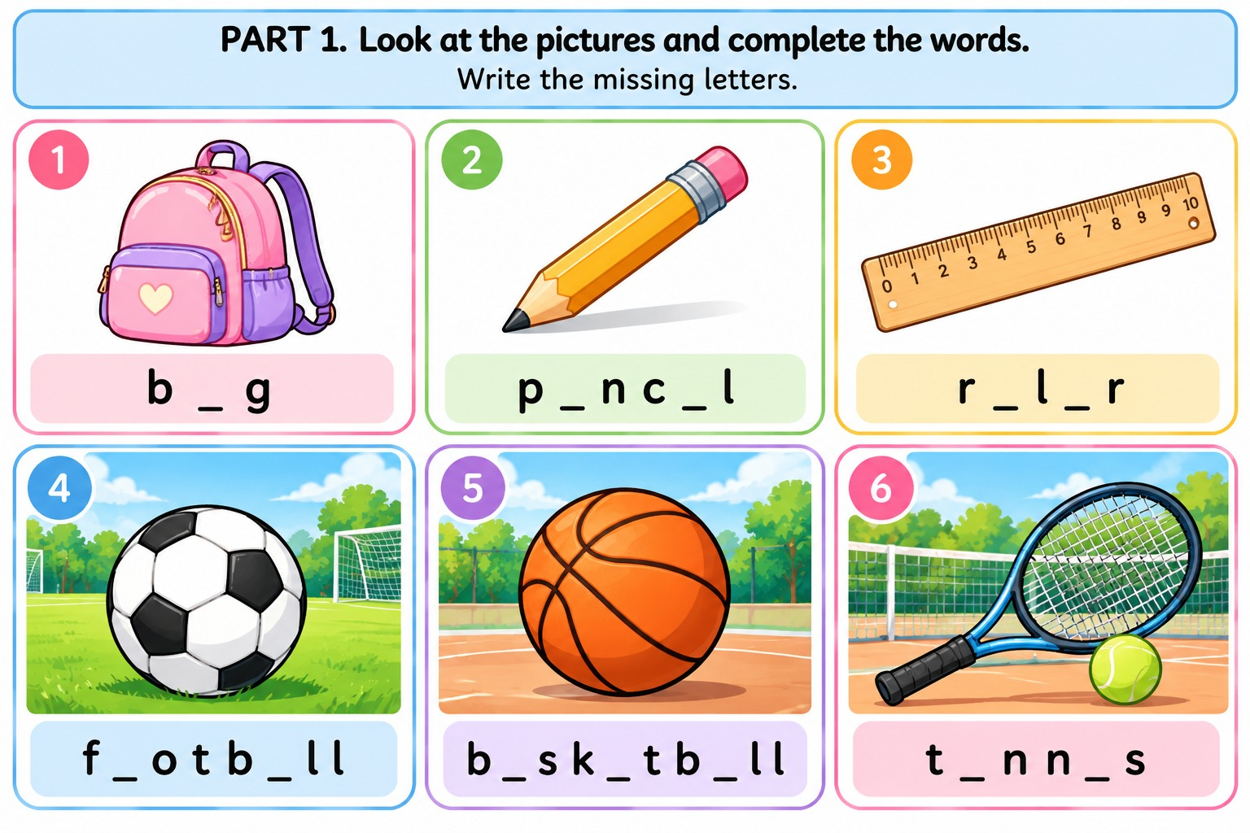
PART 2. Choose the correct word to complete the paragraph. (1 point)
My name is Emma. My birthday is 6. __________ July. I will be ten years old. I want to have a birthday 7. __________ at home. My mother will make a chocolate 8. __________. My friends will bring me some 9. __________. I am very 10. __________.
- A. in B. on C. at
- A. classroom B. party C. subject
- A. cake B. book C. bike
- A. presents B. lessons C. homework
- A. excited B. hungry C. sleepy
PART 3. Read the passage and write True or False. (2.5 points)
Hello, I'm Jack. My birthday is on the twentieth of August. I will be eleven years old. I want to invite five friends to my birthday party. The party will be at my house on Saturday afternoon. My father will buy some balloons, and my mother will make a birthday cake. We will play games and sing songs together.
- Jack's birthday is in August. __________
- He will be ten years old. __________
- He wants to invite five friends. __________
- The party will be at school. __________
- Jack's family will have a birthday cake. __________
PART 4. Match each situation with the correct response. (2 points)

No. | A |  | B
16 | Someone gives you a present. | _____ | A. How old are you?
17 | You want to know your friend's birthday. | _____ | B. Thank you!
18 | Your friend says, “Happy birthday!” | _____ | C. When is your birthday?
19 | You want to know your friend's age. | _____ | D. Nice to see you again.
20 | You meet your friend again. | _____ | E. Thank you very much!

PART 5. Write sentences using the prompts. (2.5 points)
- My birthday / in December
- I / eleven years old
- My birthday party / Saturday
- I / invite / my friends
- We / sing songs / together

