Đề số 3
PART 1. Look at the picture cues and complete the words. (2 points)
Use the picture cues to help you write the correct words.
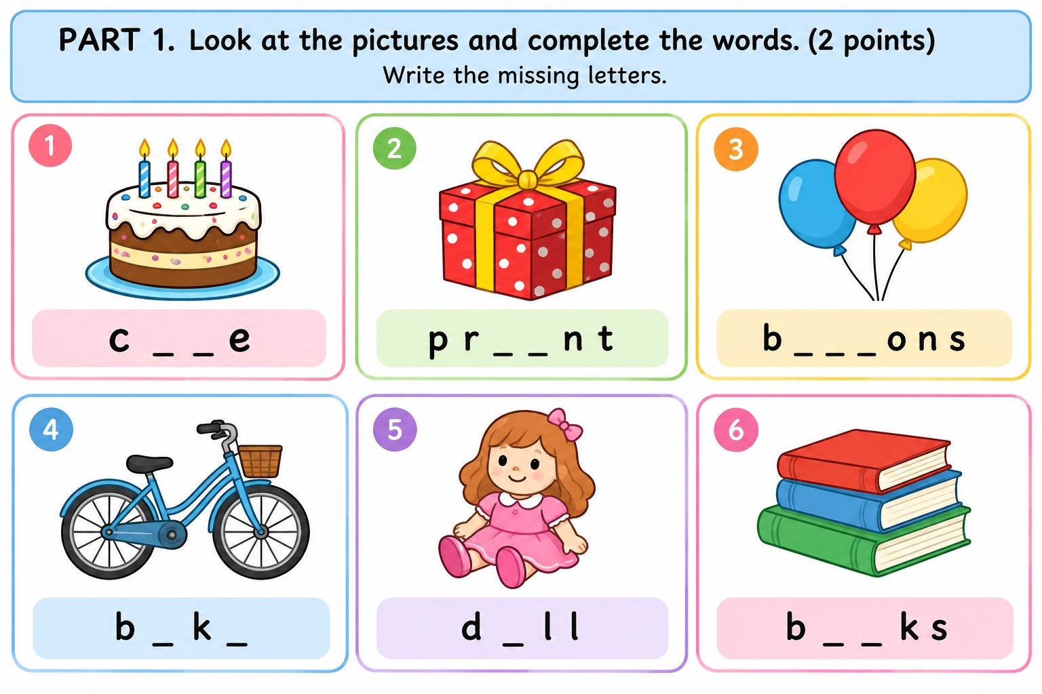
PART 2. Match the words with their meanings. (1 point)

1. Swim | A. Đọc
2. Draw | B. Nhảy múa
3. Sing | C. Bơi
4. Read | D. Vẽ
5. Dance | E. Hát

PART 3. Read the passage and choose the correct answer. (2.5 points)
My name is Andy. I am ten years old. I love sports and music. I can play football and badminton, but I can't swim. My sister Amy can swim and dance. She also likes listening to music. At weekends, we often go to the park with our parents. I ride my bike while Amy plays badminton with our mother.
How old is Andy?
A. Eight B. Nine C. Ten
Which sports can Andy play?
A. Football and badminton B. Swimming and running C. Tennis and basketball
What can't Andy do?
A. Ride a bike B. Swim C. Play football
What can Amy do?
A. Swim and dance B. Play football C. Ride a bike
What does Andy do at the park?
A. He reads books. B. He rides his bike. C. He sings songs.
PART 4. Choose the correct sentence for each picture cue. (2 points)

A. I can swim. B. I can sing. C. I can draw.

A. He can ride a bike. B. He can play the guitar. C. He can dance.

A. She likes reading. B. She likes swimming. C. She likes running.

A. They play chess. B. They play football. C. They play the piano.

A. I like drawing pictures. B. I like cooking dinner. C. I like riding a bike.
PART 5. Reorder the words to make correct sentences. (2.5 points)
21. can / What / do / you / ?
22. playing / likes / He / football / .
23. sister / My / dance / can / .
24. listening / like / I / music / to / .
25. swim / can't / My / friend / .

