Đề thi số 1
Part 1. Choose the correct answer
- Hello, my ______ is Linda.
A. name
B. old
C. friend
- How ______ are you?
A. what
B. old
C. name
- I'm fine, thank ______.
A. you
B. your
C. my
- What is ______ name?
A. you
B. she
C. your
- They ______ my friends.
A. am
B. is
C. are
Part 2. Odd one out
- A. mother – B. father – C. school
- A. eight – B. nine – C. teacher
- A. hello – B. goodbye – C. pencil
Part 3. Match the questions with the answers
Questions | Answers
1. What's your name? | a. I'm eight years old.
2. How old are you? | b. My name's Mai.
3. How are you? | c. I'm fine, thank you.

Part 4. Reorder the words
- name / My / Nam / is
- old / are / How / you / ?
- friend / This / my / is
Part 5. Look at the pictures and complete the words
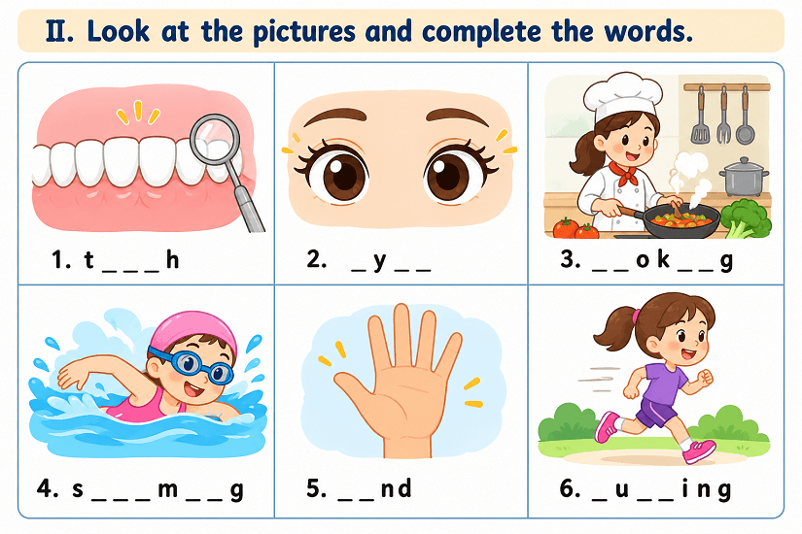
Part 6: Read the text and answer the questions
My name is Anna. I am nine years old. I am from Australia. I have got a brother. His name is Tom. He is ten years old. We are pupils at Green Primary School. Tom likes playing football and riding a bike. I like singing and reading books. We often play together after school.
1. How old is Anna?
....................................................................................
2. Where is Anna from?
....................................................................................
3. How old is her brother?
....................................................................................
4. What does Tom like doing?
....................................................................................
5. What does Anna like doing?
....................................................................................

